**Wealth Securities Inc.**

**Transaction Processing System**

**Analysis and Design**

**Team members: Professor:**

Caguioa, Armersson Mr. Ernesto Boydon

Romblon, Daveson **Project Adviser:**

Gregorio, Felix Mr. Sean Sanchez

Mendoza, Karlo Luigi

1. **Introduction**

**1.1 Project Context**

Wealth Securities Inc. (WSI) has ranked among the top 20 brokerages in the Philippines since its incorporation in November 1986. The company caters to both retail and institutional clients in the Philippines and overseas. WSI must provide the client a hassle free transaction, and with the further development of the modern world’s transactions, the company’s transaction processing system must cope up with it.

A transaction processing system (TPS) is a computerized system that performs and records the daily transactions necessary to the conduct of the business. At the lowest level of the organizational hierarchy, we find the transaction processing systems that support the day-to-day activities of the business. (Al-Mamary, Shamsuddin, & Aziati, 2014)

Wealth Securities Inc.’s transaction processing system is in charge of organization and support of turnover, announcing of minimum and maximum number of securities that can be bought or sold, market making. There is a need to incorporate the TPS of the company to the operational department of WSI with the use of mobile and internet technology.

**1.2 Purpose and Description**

**Purpose**

The project’s purpose is to identify the current issues of the transaction processing system and provides the company and its users an alternative or solution to their current issues with the use of mobile and internet technology.

**Description**

This project would provide the company and its users the following:

1. Quick access to basic charting and a clean interface
2. Real-Time Update
3. Trading Tools
4. Device Flexibility
5. Security and Reliability
6. Increased end-user productivity

**1.3 Objectives**

The objective of this project is to analyze the current transaction processing system (TPS) of Wealth Securities Inc. (WSI).

The propositioned transaction processing system (TPS) must be designed to provide an easy, fast and accurate system for the client and must be designed to help solve at least the major problems identified during the problem discovery process. As the list of problems unfolds, several common sources are likely to be discovered.

When trying to develop solutions, the team must look for the source of the problems. There are many cases of database systems that failed to satisfy the end-users because they are designed to treat the symptoms of the problems rather than their source. (Abuzo, 2015)

The team’s job is to make sure that the transaction process system corresponds to those envisioned by the end-users. In any case, the team must begin to address the following questions:

* Will the proposed system be compatible with other existing system of the company?
* Will the proposed system satisfy the needs of the company and its clients?
  1. **Scope and Limitations**

The team must recognize the existence of two sets of limits. The transaction processing system (TPS)'s scope defines the extent of the design according to operational requirements/business rules. The TPS design scope helps in defining the data flows and processes.

The proposed transaction processing system (TPS) is also subject to boundaries known as "limits", which are external to the system. Limits are imposed by existing hardware and software. The company is currently using a website and a desktop application as their TPS. Ideally, the team chooses the hardware and the software that will best compliment the system goals. In fact, the software selection is the most important aspect of system development life cycle (SDLC).

But unfortunately, in the real world, a system often must be designed around existing hardware. Thus, the scope and limitations become the factors that force the design into specific mold, and the team's job is to design the best system possible within those constraints. (Abuzo, 2015)

Note that problem definitions and the objectives sometimes must be reshaped to meet the system scope and limitations.

1. **Review of Related Literature/Study**

In ways similar to other companies, transaction is all the events that take place on a daily basis in an organization. Transaction processing system (TPS) is required to capture and process those transactions to update data on the fundamental operations of an organization.

According to Mahajan, a professor of Information technology in Amity university, the essence of a transaction processing program is that it manages data that must be left in a consistent state. This type of integrity must always be provided to the data and transaction processing.

Transaction processing systems pioneered many concepts in distributed computing and fault-tolerance computing which introduced data for reliability, availability, and performance. Most importantly, they introduced the transaction ACID properties— atomicity, consistency, isolation, and durability (JGray and AReuter, 1992)

Bloomberg app incorporated the mentioned properties of a transaction processing system and created a mobile platform for its users. It provides instant access to global business and finance news, market data and portfolio tracking tools.

Local Companies just like FirstMetroSec, Philstocks, and Col Financials already made similar mobile application and web-based platform for their transaction processing system.

Philstocks Mobile is the first and only online stock trading application officially reviewed by securities regulatory institutions it features an online trading platform that is suited for traders on-the-go, instant buying and selling of stocks, easy portfolio access, and latest feeds on market information from Philippines Stock Exchange (PSE).

Col Financials HTML5 mobile platform lets you access your trading account wherever you go. Trade stocks and options in real-time. Real-time streaming quotes. Access your account portfolio and transaction history at ease.

In establishing a mobile presence for your business or organization one of the first consider what will likely come to mind is whether you want to create a mobile application for users to download (app) or a mobile website, or perhaps both (Summerfield, 2000)

Summerfield reported that, when it comes to deciding whether to build a mobile application or website, the appropriate choice depends on the end goals of the company or clients. Mobile application offers a much personalized touch on daily usage of the users and can perform complex calculation and reporting while mobile websites offers a larger accessibility and availability function than mobile applications.

The more often the company can get customers involved with their app, the sooner customers will be inclined to buy their product and/or service. In advertising, this is called the “[effective frequency](http://en.wikipedia.org/wiki/Effective_frequency)”: as a rule of thumb, hearing and/or seeing your brand approximately 20 times is what will get you truly noticed. (Haselmayr, 2014)

**Appendix:**

**Context Diagram**

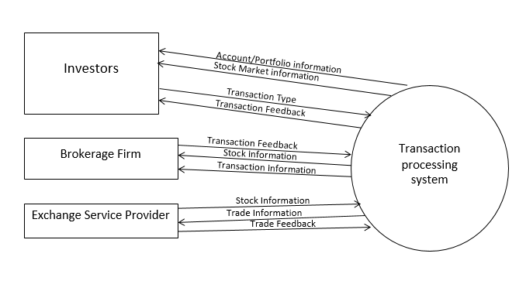

**Leveled Diagram**

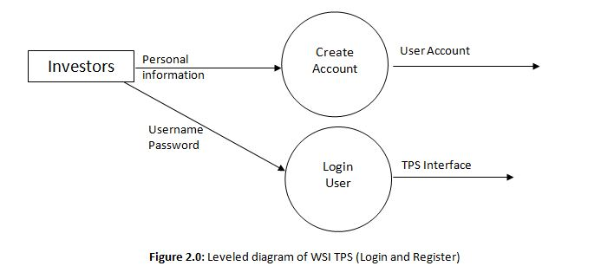

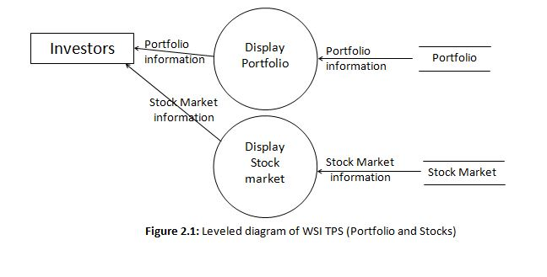

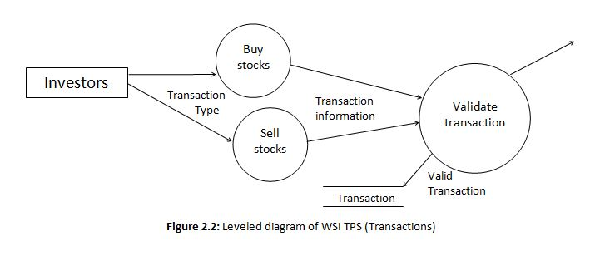

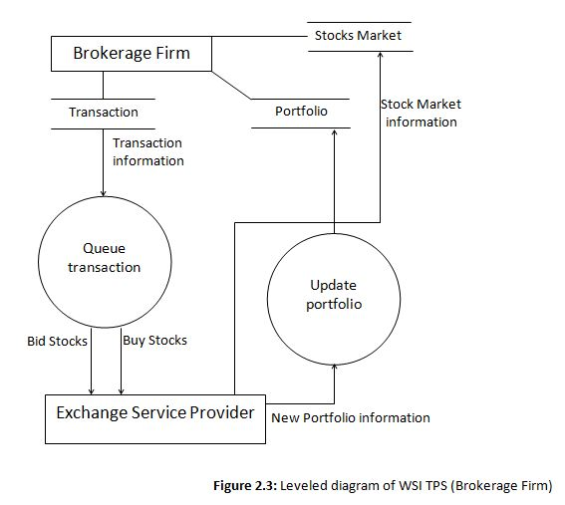

**ERD**

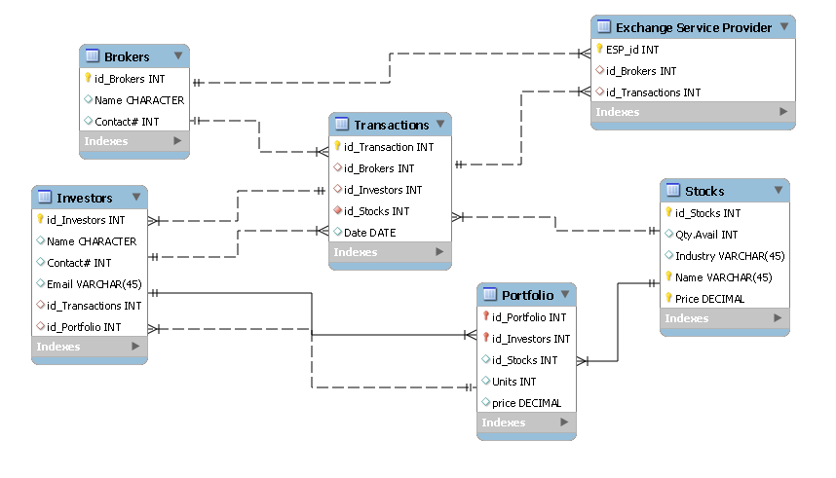

**Process Specification**

